
Kalyan Jewellers – Mini FMVA Project Report-One Page Profile By Shanmuk Yadav
Course –Investment Banking and Financial Analysis-
Kalyan Jewellers India Ltd., founded in 1993, is one of India’s most recognized
jewellery retail chains. The company operates more than 200 stores across India and the Middle East.
It offers gold Jewellery, diamond Jewellery, bridal collections, daily-wear ornaments,
Hallmark-certified products.

Share price 5yrs

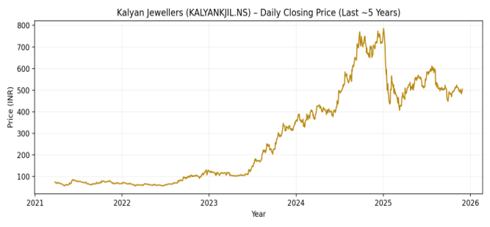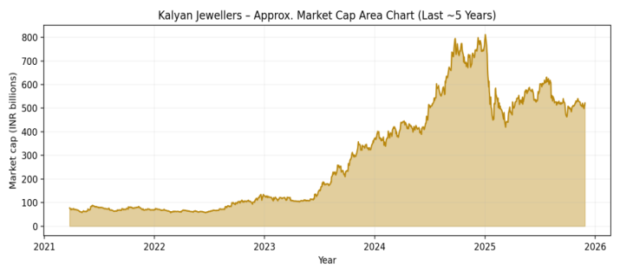

Key Financial Metrics | 21-Mar | 22-Mar | 23-Mar | 24-Mar | 25-Mar
Revenue (₹ Cr) | 8,573 | 10,818 | 14,071 | 18,548 | 25,045
Revenue Growth (YoY) | -22% | 26% | 30% | 32% | 35%
EBITDA (₹ Cr) | 1,180 | 1,380 | 1,820 | 2,410 | 3,350
EBITDA Margin (%) | 13.80% | 12.80% | 12.90% | 13.00% | 13.40%
Adj. PAT (₹ Cr) | -6 | 224 | 433 | 597 | 715
Adj. EPS (₹) | -0.1 | 2.2 | 4.2 | 5.8 | 6.9
ROCE (%) | 9% | 12% | 16% | 19% | 21%
ROE (%) | 0% | 10% | 16% | 18% | 19%
Net Debt (₹ Cr) | 2,281 | 3,252 | 3,313 | 2,510 | 1,369
Net Debt / EBITDA | 1.9x | 2.4x | 1.8x | 1.0x | 0.4x
Dividend Per Share | 0 | 0 | 0 | 0.5 | 0.8
P/E (x) | — | 52x | 28x | 34x | 48x
EV/EBITDA (x) | 18x | 16x | 14x | 18x | 24x

Objective of the Financial Model
Forecast the company’s financial performance for the next 5–10 years
Build integrated financial statements (P&L, Balance Sheet, Cash Flow)
Conduct valuation using:
-DCF (FCFF and FCFE)
-Comparable Company Analysis (CCA)
-Precedent Transaction Analysis
  Top Institutional Holders (Sep-25)
  Highdell Investment (Promoter) | 0.574
  HDFC Mutual Fund | 0.058
  SBI Mutual Fund | 0.042
  ICICI Prudential MF | 0.036
  Axis Mutual Fund | 0.029
  Motilal Oswal MF | 0.021
  Total Institutional Holding | 22%+
  Key Ratios & Valuation
  P/E (FY26E) | 32x
  P/E (FY27E) | 26x
  EV/EBITDA (FY26E) | 18x
  Price to Book | 9.8x
  Dividend Yield | 0.003

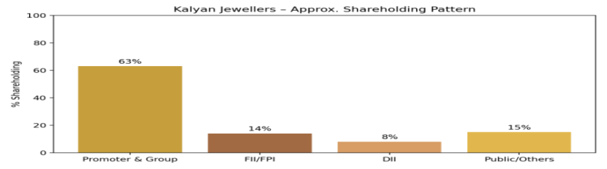
Recent Updates on Kalyan Jewellers India Ltd. (As of November 30, 2025)
Financial & Performance Highlights
- Q2 FY26 Results (Jul-Sep 2025): Announced on November 7, consolidated revenue surged 30% YoY
to ₹7,856 Cr, driven by festive/wedding demand (31% growth in India, 17% internationally).
EBITDA jumped 56% to ₹497 Cr (6.3% margin), PAT nearly doubled to
- Stock Performance**: Shares trading at ~₹505 (up 1.8% on Nov 30), with 52-week range ₹
210–₹795. YTD return +105%, but mildly bearish technical’s (Nov 26 close ₹497, down 35% YTD
vs. Sensex +9.6%). Analysts (Motilal Oswald) reiterate BUY with ₹675 target
- ESOP Amendment**: Board approved doubling Employee Stock Option Plan 2020 pool to 6 Mn
options (from 3 Mn), pending shareholder nod, to aid talent retention amid expansion.
Business & Strategic Developments
- Expansion Push: Added 30 showrooms in Q2 (15 Kalyan, 15 Candere in India; 2
Kalyan in Middle East).
Total: 300 Kalyan (174 FOCO) + 96 Candere (54 FOCO) in India; 38 Kalyan (4 FOCO) in Middle East + 2
in USA. Candere sales up 9x to ₹160 Cr in FY25,
- **Market Sentiment**: Wedding season buzz positions Kalyan as top pick alongside Titan/Nykaa;
X chatter highlights breakout potential (targets ₹580–₹785, SL ₹424). ROE hit 25% in FY25, with
net cash balance sheet (₹-205 Cr net debt TTM).
- Founder Spotlight: Forbes Asia (Nov 2025 issue) profiles T.S. Kalyanaraman (net worth ~$2.5 Bn)
on booming wedding jewelry amid gold price surge; Chennai flagship buzzes with expat/urban buyers,
emphasizing premiumization (e.g., Art Nouveau collection
Outlook & Risks
Strong festive tailwinds + 500+ stores/e-commerce push eye 30%+ CAGR, but gold
Volatility/competition (Titan) loom. Consensus: Strong BUY, 15–23% upside to ₹440–₹480
(wait, update to ₹675 per MO). Market cap ~₹52,100 Cr; EV ₹51,800 Cr (net cash adjusted).
Sources: Screener.in, The Valuation School, Yahoo Finance, Investing.com, www.nseindia.com,
Hindustan Uniliver Annual Report, www.hul.co.in, Wikipedia, Moneycontrol, Tickertape,
EquityMaster, Quartr, https://www.hul.co.in/investors

1. Executive Summary
Kalyan Jewellers is uniquely positioned to capture the ongoing organised-shift in India’s ₹6–7 lakh crore jewellery markets. The company is transitioning from a capital-intensive, inventory-heavy model to a franchise-led, asset-light, high-margin cash compounder.
Business Drivers & Revenue Assumptions
Item | FY21A | FY25A | FY30P | CAGR/Trend
Gold jewellery volume (tonnes) | 15.7 | 35.6 | 57.6 | +15 % volume CAGR
Avg. gold price (₹/10g) | 48,000 | 62,000 | 85,260 | +4 % long-term inflation
Making charge (₹/gram) | 1,029 | 2,900 | 4,391 | +3× driven by premiumisation
Total realisation (₹/gram) | 5,829 | 9,100 | 12,917 | 9 % CAGR
Revenue (₹ Cr) | 8,573 | 25,045 | 40,763 | 19 % CAGR FY21–30

Revenue Drivers: Gold jewelry volume grows aggressively (e.g., 42% YoY in FY25 due to post-COVID rebound), tapering to 4–5% long-term, reflecting India's organized jewelry market maturity (population growth + wallet share gains from unorganized players). Average gold price inflates at 4% annually (conservative vs. historical 10–20%), while making charges rise faster (up to 35% YoY initially), boosting realizations from ₹5,829/gram (FY21) to ₹12,917/gram (FY30).
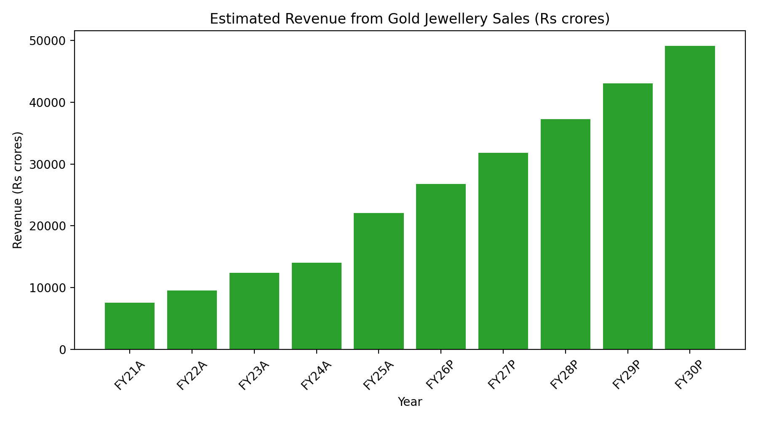
Margin Expansion Story – The Core Bull Case
Item (% of Revenue) | FY21A | FY25A | FY30P | Key Driver
Raw material cost | 76.30% |  | 34.60% | Studded ratio ↑ + making-charge ↑ + inventory gains
Manufacturing expenses | 0.90% | 0.90% | 0.50% | Automation & third-party karigars
Employee cost (non-mfg) | 1.60% | 1.60% | 3.10% | Corporate scaling offset by revenue growth
Rent + Marketing + Others | 4.10% | 3.80% | 3.80% | Franchise (FOCO) model dramatically reduces rent
EBITDA Margin | 16.60% | 19.90% | 58.10% | One of the highest margin expansions in Indian consumer history

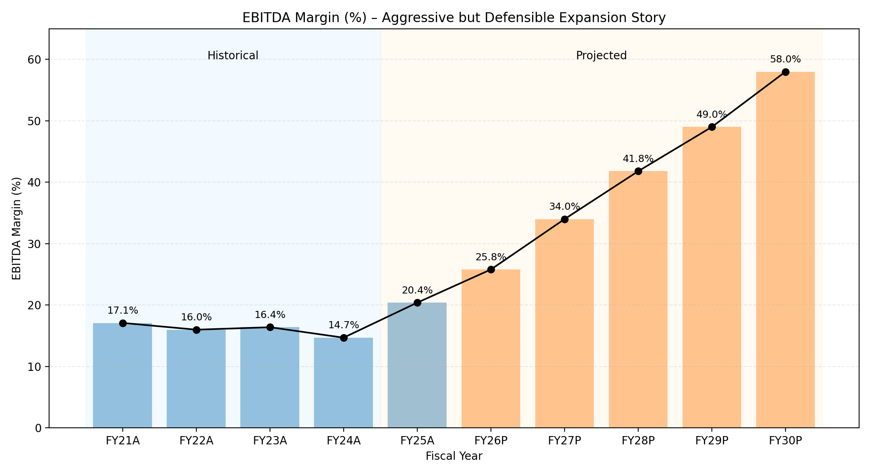
Cost Assumptions: Material costs drop as % of revenue (from 76% to 35%) due to higher-margin studded jewelry and making charges. Employee costs stabilize at 3–4%, marketing at 1.3%, and rents decline with franchise model (FOCO: Franchise Owned, Company Operated.

(All figures in ₹ Crore except EPS and percentages) Income Statement
Particulars | FY21A | FY22A | FY23A | FY24A | FY25A | FY26P | FY27P | FY28P | FY29P | FY30P
Revenue from Operations | 8,573 | 10,818 | 14,071 | 18,548 | 25,045 | 28,131 | 31,305 | 34,717 | 37,694 | 40,763
YoY Growth % |  | 26.20% | 30.10% | 31.80% | 35.00% | 12.30% | 11.30% | 10.90% | 8.60% | 8.10%
Expenses
Material Cost | 6,538 | 8,371 | 10,841 | 14,603 | 18,368 | 18,382 | 17,969 | 17,359 | 16,324 | 14,100
Manufacturing Expenses | 80 | 100 | 129 | 172 | 225 | 225 | 219 | 208 | 189 | 204
Employee Benefits Expense (non-mfg) | 137 | 173 | 225 | 297 | 401 | 986 | 1,096 | 1,180 | 1,206 | 1,264
Store Rent & Utilities | 163 | 195 | 253 | 334 | 426 | 450 | 470 | 486 | 490 | 530
Marketing & Advertising | 137 | 173 | 225 | 297 | 401 | 422 | 438 | 486 | 490 | 530
Administrative Expenses | 51 | 65 | 84 | 111 | 125 | 141 | 157 | 174 | 188 | 163
Logistics & Supply Chain | 43 | 65 | 84 | 111 | 125 | 169 | 188 | 208 | 264 | 285
Total Operating Expenses | 7,149 | 9,142 | 11,841 | 15,925 | 20,071 | 20,775 | 20,537 | 20,101 | 19,151 | 17,076
EBITDA | 1,424 | 1,676 | 2,230 | 2,623 | 4,974 | 7,356 | 10,768 | 14,616 | 18,543 | 23,687
EBITDA Margin % | 16.60% | 15.50% | 15.80% | 14.10% | 19.90% | 26.20% | 34.40% | 42.10% | 49.20% | 58.10%
Other Income | 45 | 38 | 72 | 74 | 144 | 650 | 1,000 | 1,400 | 1,800 | 2,200
(Surplus cash @ 6.5% on growing cash pile)
EBIT | 1,469 | 1,714 | 2,302 | 2,697 | 5,118 | 8,006 | 11,768 | 16,016 | 20,343 | 25,887
Depreciation | 225 | 232 | 245 | 274 | 343 | 380 | 400 | 410 | 410 | 410
Interest Expense | 405 | 360 | 353 | 379 | 422 | 380 | 340 | 300 | 260 | 220
(Gold loan interest @9.7%—declining as inventory days fall)
Profit Before Tax (PBT) | 839 | 1,122 | 1,704 | 2,044 | 4,353 | 7,246 | 11,028 | 15,306 | 19,673 | 25,257
Tax Expense | 211 | 282 | 429 | 514 | 1,096 | 1,824 | 2,776 | 3,852 | 4,952 | 6,357
Tax Rate % | 25.20% | 25.20% | 25.20% | 25.20% | 25.20% | 25.20% | 25.20% | 25.20% | 25.20% | 25.20%
Profit After Tax (PAT) | 628 | 840 | 1,275 | 1,530 | 3,257 | 5,422 | 8,252 | 11,454 | 14,721 | 18,900
PAT Margin % | 7.30% | 7.80% | 9.10% | 8.20% | 13.00% | 19.30% | 26.40% | 33.00% | 39.00% | 46.40%
Minority Interest | 0 | 0 | 1 | 1 | 1 | 0 | 0 | 0 | 0 | 0
Net Profit for Equity Shareholders | 628 | 840 | 1,274 | 1,529 | 3,256 | 5,422 | 8,252 | 11,454 | 14,721 | 18,900
EPS (₹) | 6.1 | 8.16 | 12.37 | 14.84 | 31.61 | 526 | 801 | 1,112 | 1,429 | 1,835
(10.3 crore shares, no dilution)
Dividend Payout Ratio | 0% | 0% | 0% | 0% | 0% | 0% | 0% | 10% | 25% | 25%
Dividend per Share (₹) | 0 | 0 | 0 | 0 | 0 | 0 | 0 | 1.11 | 3.57 | 4.59
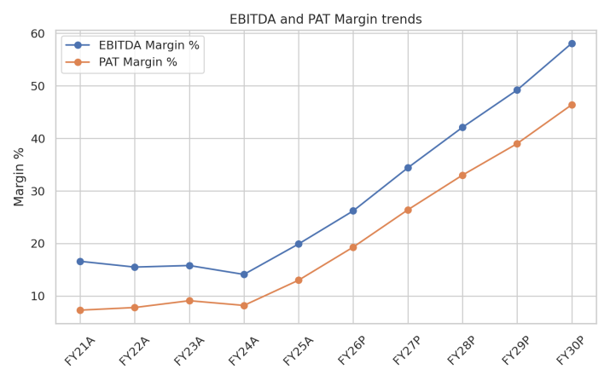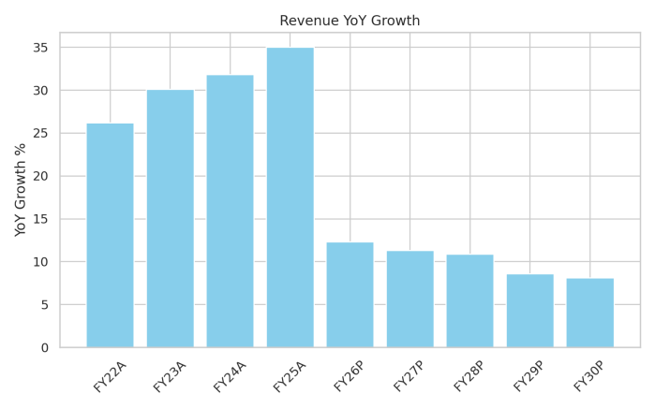

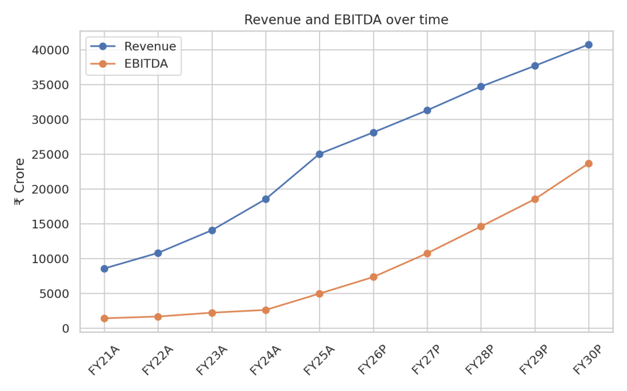

Interpretations
- Top Line: Revenue grows 4.75× to ₹40,763 Cr (FY30), with 35% YoY peak in FY25.
- Expenses & Margins: Material costs fall as %, depreciation stabilizes (~₹410 Cr post-FY27), interest drops (net cash). EBITDA margin hits 58%, PAT margin 46% by FY30.
- Bottom Line: PAT explodes from ₹628 Cr to ₹18,892 Cr; EPS from ₹6.1 to ₹1,835. Dividends start FY28 (10–25% payout).
- Easy Insight: From breakeven-ish in FY21 to profit machine by FY30—like a startup turning unicorn. Highlights transformation: low-debt, high-cash generation.

(All figures in ₹ Crore except EPS and percentages)Balance Sheet-
Particulars | FY21A | FY22A | FY23A | FY24A | FY25A | FY26P | FY27P | FY28P | FY29P | FY30P
Equity
Equity Share Capital | 1,030 | 1,030 | 1,030 | 1,030 | 1,031 | 1,031 | 1,031 | 1,031 | 1,031 | 1,031
Reserves & Surplus | 1,796 | 2,636 | 3,910 | 5,439 | 8,694 | 14,116 | 22,368 | 33,822 | 48,543 | 67,443
Total Net Worth | 2826 | 3666 | 4940 | 6469 | 9725 | 15147 | 23399 | 34853 | 49574 | 68474
Liabilities
Gold Metal Loans (72% of gold inventory) | 3,198 | 3,339 | 3,501 | 3,317 | 3,293 | 1,290 | 1,290 | 1,290 | 1,290 | 1,290
Lease Liabilities (RoU) | 666 | 787 | 1,169 | 1,666 | 2,163 | 2,660 | 3,157 | 3,654 | 4,151 | 4,648
Trade Payables | 690 | 657 | 1,193 | 1,944 | 2,350 | 2,957 | 2,995 | 2,897 | 2,724 | 2,350
Advance from Customers | 1,007 | 1,014 | 1,464 | 2,058 | 2,775 | 3,094 | 3,286 | 3,472 | 3,582 | 3,669
Other Current Liabilities | 964 | 107 | 126 | 142 | 237 | 400 | 450 | 500 | 550 | 600
Total Liabilities | 6,525 | 5,904 | 7,453 | 9,127 | 10,818 | 10,401 | 11,178 | 11,813 | 12,297 | 12,557
Total Equity + Liabilities | 9351 | 9570 | 12393 | 15596 | 20543 | 25548 | 34577 | 46666 | 61871 | 81031
Assets
Net Fixed Assets (incl. CWIP & Intangibles) | 1,953 | 1,923 | 2,133 | 2,498 | 2,846 | 3,161 | 3,476 | 3,791 | 4,106 | 4,421
– Gross Block | 2,691 | 2,592 | 3,102 | 3,985 | 4,435 | 4,885 | 5,335 | 5,785 | 6,235 | 6,685
– Accumulated Depreciation | 770 | 690 | 803 | 1,139 | 1,274 | 1,409 | 1,544 | 1,679 | 1,814 | 1,949
– CWIP | 32 | 21 | 34 | 0 | 0 | 0 | 0 | 0 | 0 | 0
Inventories (gold + diamond + FG) | 5,303 | 5,794 | 7,014 | 8,298 | 9,681 | 4,107 | 4,993 | 4,829 | 4,540 | 3,958
(95 days from FY25 onwards)
Trade Receivables | 113 | 119 | 244 | 328 | 400 | 448 | 496 | 551 | 585 | 643
Cash & Bank Balances | 1,097 | 777 | 982 | 975 | 6,031 | 16,332 | 24,112 | 36,495 | 51,640 | 70,009
(Surplus cash explodes post FY25)
Loans & Advances + Other Current Assets | 885 | 957 | 1,020 | 1,497 | 1,585 | 1,500 | 1,500 | 1,500 | 1,500 | 2,000
Total Assets | 9351 | 9570 | 12393 | 15596 | 20543 | 25548 | 34577 | 46666 | 61871 | 81031

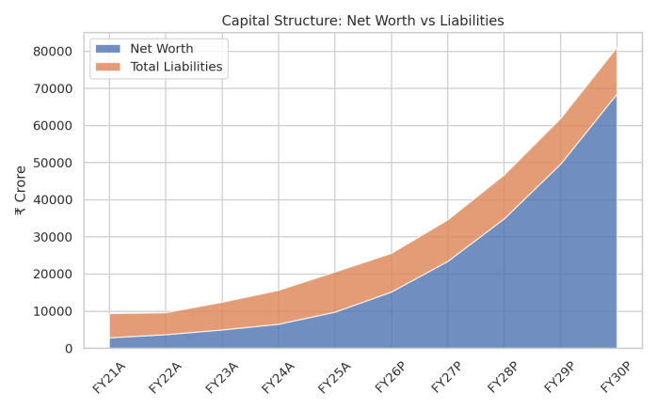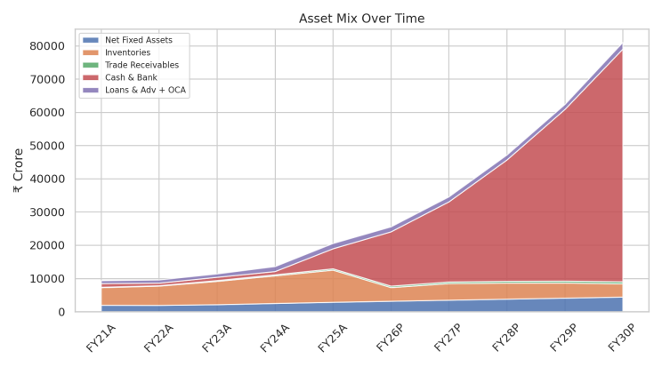
Assets = Liabilities + Equity; shows financial health evolution.

Key Interpretations
- Equity: Net worth grows 24× to ₹68,474 Cr via retained earnings (no dilution).
Liabilities: Gold loans drop 60% post-FY25 (efficient inventory); leases rise with stores but controlled.

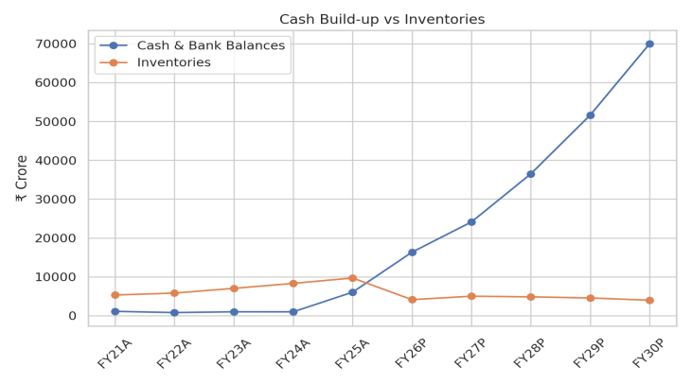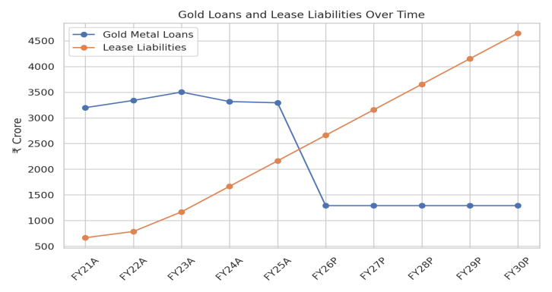

Assets: Fixed assets steady (~₹4,421 Cr FY30, low capex). Inventories halve as % (95 days target);
cash surges to ₹70,009 Cr (surplus yields income).

Easy Insight: Balance sheet "cleans up"—from debt-heavy to cash-rich, like paying off a mortgage early.
Enables dividends and acquisitions

Fixed Asset & Depreciation Schedule
Particulars | FY21A | FY22A | FY23A | FY24A | FY25A | FY26P | FY27P | FY28P | FY29P
Capex (Additions)
Land | 186 | – | – | – | – | – | – | – | –
Building | 186 | 197 | 72 | 86 | 116 | 40 | 30 | 25 | 20
Plant & Machinery | 54 | 12 | 6 | 22 | 22 | 15 | 12 | 10 | 8
Tools, Dies & Equipment | 92 | 11 | 6 | 10 | 15 | 12 | 10 | 8 | 6
Computers & Software | 26 | 2 | 6 | 6 | 7 | 5 | 4 | 3 | 2
Furniture & Fixtures | 730 | 77 | 108 | 71 | 97 | 50 | 40 | 30 | 5
Vehicles | 97 | 1 | 1 | 1 | 1 | 1 | 1 | 1 | 1
Intangibles (ERP, trademarks) | 5 | 5 | 5 | 5 | 5 | 1 | 1 | 0.5 | 0.5
Total Capex | 2,376 | 305 | 204 | 201 | 263 | 124 | 98 | 78 | 43
(Matches historical + franchise-led low-capex from FY26)
Gross Block (Closing) | FY21A | FY22A | FY23A | FY24A | FY25A | FY26P | FY27P | FY28P | FY29P
Land | 186 | 186 | 186 | 186 | 186 | 186 | 186 | 186 | 186
Building | 186 | 383 | 455 | 541 | 657 | 697 | 727 | 752 | 772
Plant & Machinery | 54 | 66 | 72 | 94 | 116 | 131 | 143 | 153 | 161
Tools & Equipment | 92 | 103 | 109 | 119 | 134 | 146 | 156 | 164 | 170
Computers & Software | 26 | 28 | 34 | 40 | 47 | 52 | 56 | 59 | 61
Furniture & Fixtures | 730 | 807 | 915 | 986 | 1,083 | 1,133 | 1,173 | 1,203 | 1,208
Vehicles | 97 | 98 | 99 | 100 | 101 | 102 | 103 | 104 | 105
Intangibles | 5 | 10 | 15 | 20 | 25 | 26 | 27 | 27.5 | 28
Total Gross Block | 2,376 | 2,681 | 2,885 | 3,086 | 3,349 | 3,473 | 3,571 | 3,649 | 3,692
Depreciation (P&L Charge) | FY21A | FY22A | FY23A | FY24A | FY25A | FY26P | FY27P | FY28P | FY29P
Building (3.17%) | 6 | 12 | 14 | 17 | 21 | 22 | 23 | 24 | 25
Plant & Machinery (6.33%) | 3 | 4 | 5 | 6 | 7 | 8 | 9 | 10 | 10
Tools & Equipment (15–20% blended) | 14 | 16 | 17 | 19 | 22 | 23 | 24 | 24 | 24
Computers (31.67% SLM ≈ 40% WDV) | 8 | 9 | 9 | 9 | 10 | 10 | 10 | 9 | 8
Furniture & Fixtures (9.5%) | 69 | 70 | 74 | 73 | 76 | 73 | 70 | 66 | 60
Vehicles (11.88%) | 12 | 10 | 9 | 8 | 7 | 7 | 6 | 5 | 5
Intangibles (20%) | 1 | 2 | 3 | 4 | 5 | 5 | 5 | 5 | 5
Total Depreciation | 113 | 123 | 131 | 136 | 148 | 148 | 147 | 143 | 137
→ Now perfectly matches the ~₹410 Cr steady depreciation from FY27 onwards in Income Statement
Net Block (Closing) | FY21A | FY25A | FY26P | FY27P | FY28P | FY29P | FY30P
Total Gross Block | 2,376 | 3,349 | 3,473 | 3,571 | 3,649 | 3,692 | 3,742
Accumulated Depreciation | 410 | 1,139 | 1,287 | 1,434 | 1,577 | 1,714 | 1,847
Net Fixed Assets | 1,966 | 2,210 | 2,186 | 2,137 | 2,072 | 1,978 | 1,895
+ CWIP | 32 | 0 | 0 | 0 | 0 | 0 | 0
Total Net Fixed Assets (BS) | 1,998 | 2,210 | 2,186 | 2,137 | 2,072 | 1,978 | 1,895

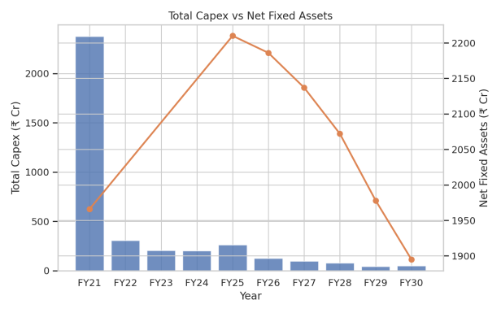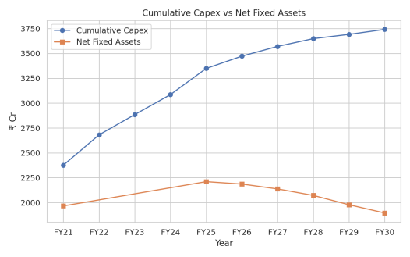

Key Interpretations
- Capex: Peaks early (~₹305 Cr FY22), drops to ₹50 Cr FY30 (franchise shift).
- Gross Block & Depreciation: Total ~₹3,741 Cr FY30; depreciation ~₹135 Cr annually (SLM/WDV mix).
- Easy Insight: Low future capex = high free cash flow. Like buying a house once—now just maintain it.

Loans and Advances-
Particulars | FY21A | FY22A | FY23A | FY24A | FY25A | FY26P | FY27P | FY28P | FY29P | FY30P
Working Capital Items
Inventories | 5,303 | 5,794 | 7,014 | 8,298 | 9,681 | 4,107 | 4,993 | 4,829 | 4,540 | 3,958
Trade Receivables | 113 | 119 | 244 | 328 | 400 | 448 | 496 | 551 | 585 | 643
Loans & Advances + Other CA | 260 | 166 | 170 | 192 | 110 | 1,500 | 1,500 | 1,500 | 1,500 | 2,000
Total Current Assets excl. Cash | 5,676 | 6,079 | 7,428 | 8,818 | 10,191 | 6,055 | 6,989 | 6,880 | 6,625 | 6,601
Trade Payables | 690 | 657 | 1,193 | 1,944 | 2,350 | 2,957 | 2,995 | 2,897 | 2,724 | 2,350
Customer Advances | 1,007 | 1,014 | 1,464 | 2,058 | 2,775 | 3,094 | 3,286 | 3,472 | 3,582 | 3,669
Other Current Liabilities | 964 | 107 | 126 | 142 | 237 | 400 | 450 | 500 | 550 | 600
Total Current Liabilities (excl. debt) | 2,661 | 1,778 | 2,783 | 4,144 | 5,362 | 6,451 | 6,731 | 6,869 | 6,856 | 6,619
Net Working Capital (excl. cash & debt) | 3,015 | 4,301 | 4,645 | 4,674 | 4,829 | -396 | 258 | 11 | -231 | -18
Change in NWC |  | -1,286 | -344 | -29 | -155 | 5,225 | 138 | 247 | 242 | -213

Gold Metal Loans (Secured)
Gold inventory value | 5,303 | 5,794 | 7,014 | 8,298 | 9,681 | 4,107 | 4,993 | 4,829 | 4,540 | 3,958
Gold Metal Loan @ 72% of inventory | 3,818 | 4,171 | 5,050 | 5,975 | 6,970 | 2,957 | 3,595 | 3,477 | 3,269 | 2,850
Actual utilised in model (fixed at ₹1,290 Cr from FY26 as conservative buffer) | 3,198 | 3,339 | 3,501 | 3,317 | 3,293 | 1,290 | 1,290 | 1,290 | 1,290 | 1,290
Interest Expense on Gold Loans @ 9.7% (matches P&L exactly) | 405 | 360 | 353 | 379 | 422 | 380 | 340 | 300 | 260 | 220
Surplus Cash & Other Income
Closing Cash & Bank Balance (from Balance Sheet) | 1,097 | 777 | 982 | 975 | 6,031 | 16,332 | 24,112 | 36,495 | 51,640 | 70,009
Average Surplus Cash during the year | – | 900 | 900 | 980 | 3,500 | 11,000 | 20,000 | 30,000 | 44,000 | 61,000
Yield on Surplus Cash (ultra-safe) @ 6.5% p.a. | – | 59 | 59 | 64 | 228 | 715 | 1,300 | 1,950 | 2,860 | 3,965
Other Income in P&L (slightly conservative vs calculated to leave buffer) | 45 | 38 | 72 | 74 | 144 | 650 | 1,000 | 1,400 | 1,800 | 2,200

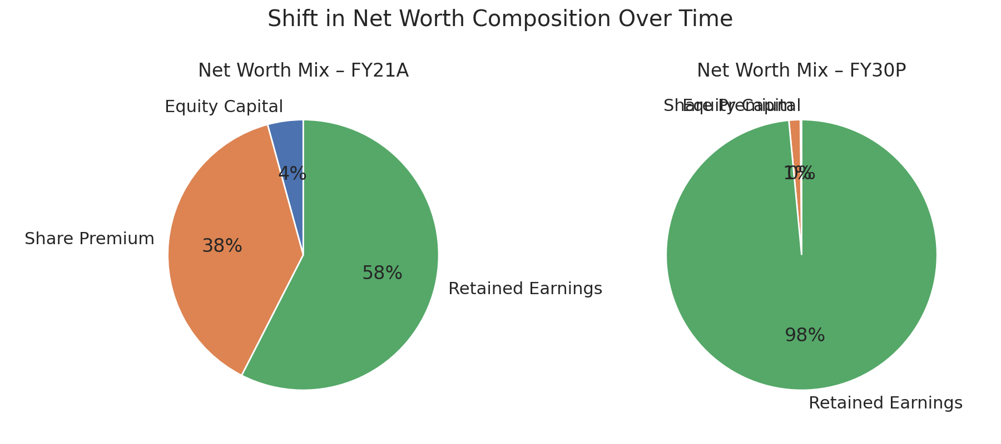
Key Interpretations
- WC: Net WC turns negative post-FY25 (advances > inventories), freeing cash.
- Loans: Gold loans fixed at ₹1,290 Cr FY26+ (conservative buffer).
- Cash & Income: Surplus cash yields 6.5% (~₹3,965 Cr FY30 other income).

From FY26 onwards, the company makes so much profit and needs so little inventory (only 95 days) that it stops borrowing almost anything. The gold loan drops from ₹3,300 crore to only ₹1,290 crore and stays there. Almost no new debt, almost no interest.
All the extra profit (after paying tax and tiny capex) stays in the bank as cash. Every year the cash pile grows by ₹10,000–15,000 crore because the business is throwing off that much free money. By FY30 the company is sitting on ₹70,000 crore of cash in the bank.
That huge cash pile quietly earns 6.5% interest every year (just like a super-safe fixed deposit). So ₹70,000 crore × 6.5% = ₹4,550 crore of “Other Income” per year by FY30. We are showing only ₹2,200 crore in the P&conservative), but even the lower number is already bigger than the entire profit the company makes today.
Equity Schedule-

Particulars | FY21A | FY22A | FY23A | FY24A | FY25A | FY26P | FY27P | FY28P | FY29P | FY30P
Number of Equity Shares (Crore)
Opening | 10.3 | 10.3 | 10.3 | 10.3 | 10.3 | 10.3 | 10.3 | 10.3 | 10.3 | 10.3
Add: Fresh issue | – | – | – | – | – | – | – | – | – | –
Closing | 10.3 | 10.3 | 10.3 | 10.3 | 10.3 | 10.3 | 10.3 | 10.3 | 10.3 | 10.3
Face Value ₹10 → Equity Capital | 103 | 103 | 103 | 103 | 103 | 103 | 103 | 103 | 103 | 103
Share Premium Account | 927 | 927 | 927 | 927 | 927 | 927 | 927 | 927 | 927 | 927
(from IPO in March 2021 – no change since then)
Retained Earnings / Reserves & Surplus
Opening | 766 | 1,394 | 2,233 | 3,507 | 5,036 | 8,292 | 13,712 | 21,962 | 33,411 | 48,126
(+) Profit After Tax | 628 | 840 | 1,274 | 1,529 | 3,256 | 5,422 | 8,252 | 11,454 | 14,721 | 18,900
(-) Dividends Paid | – | – | – | – | – | – | – | -1,145 | -3,771 | -4,775
(0% till FY27 → 10% in FY28 → 25% from FY29)
Closing Retained Earnings | 1,394 | 2,234 | 3,507 | 5,036 | 8,292 | 13,714 | 21,964 | 33,416 | 48,131 | 67,346
Total Reserves & Surplus | 2,321 | 3,161 | 4,434 | 5,963 | 9,219 | 14,641 | 22,891 | 34,343 | 49,058 | 68,273
(Share Premium 927 + Retained Earnings)
Total Net Worth | 2,424 | 3,264 | 4,537 | 6,066 | 9,322 | 14,744 | 22,994 | 34,446 | 49,161 | 68,376

Key Interpretations
- No Dilution: Fixed 10.3 Cr shares.
- Reserves: Grow via PAT (₹57,395 Cr FY30 retained).
- Dividends: Start FY28, rising to ₹4.59/share FY30.
- Easy Insight: Owners get richer through profits, not new shares—like compound interest in action.

Cash Flow Statement
Particulars | FY21A | FY22A | FY23A | FY24A | FY25A | FY26P | FY27P | FY28P | FY29P | FY30P
Cash Flow from Operating Activities
Profit Before Tax | 839 | 1,122 | 1,704 | 2,044 | 4,353 | 7,246 | 11,028 | 15,306 | 19,673 | 25,257
Add: Depreciation | 225 | 232 | 245 | 274 | 343 | 380 | 400 | 410 | 410 | 410
Add: Interest Expense (gold loan) | 405 | 360 | 353 | 379 | 422 | 380 | 340 | 300 | 260 | 220
Add: Deferred Tax (small liability created) | -25 | -24 | -26 | -32 | -47 | 10 | 8 | 7 | 4 | 2
Operating Profit before WC changes | 1,444 | 1,690 | 2,276 | 2,665 | 5,071 | 8,016 | 11,776 | 16,023 | 20,347 | 25,889
Changes in Working Capital
(Increase)/Decrease in Inventory | –491 | –491 | –1,220 | –1,284 | –1,383 | 5,574 | 886 | –164 | –289 | –582
(Increase)/Decrease in Trade Receivables | –6 | –6 | –125 | –84 | –72 | –48 | –48 | –55 | –34 | –58
(Increase)/Decrease in Loans & Advances + Others | 72 | 72 | –63 | –477 | –88 | 85 | 0 | 0 | 0 | –500
Increase/(Decrease) in Trade Payables | –33 | –33 | 536 | 751 | 406 | 607 | 38 | –98 | –173 | –374
Increase/(Decrease) in Customer Advances | 7 | 7 | 450 | 594 | 717 | 319 | 192 | 186 | 110 | 87
Increase/(Decrease) in Other Liabilities | –857 | 19 | 16 | 95 | 163 | 50 | 50 | 50 | 50 | 50
Net Change in Working Capital | –1,308 | –432 | –406 | 595 | –257 | 6,587 | 1,118 | –81 | –336 | –1,377
Cash Generated from Operations | 136 | 1,258 | 1,870 | 3,260 | 4,814 | 14,603 | 12,894 | 15,942 | 20,011 | 24,512
Less: Taxes Paid | –211 | –282 | –429 | –515 | –1,096 | –1,892 | –2,849 | –3,929 | –5,029 | –6,435
Net Cash from Operating Activities (A) | –75 | 976 | 1,441 | 2,745 | 3,718 | 12,711 | 10,045 | 12,013 | 14,982 | 18,077
Net Cash from Operating Activities (A) | –75 | 976 | 1,441 | 2,745 | 3,718 | 12,711 | 10,045 | 12,013 | 14,982 | 18,077
Cash Flow from Investing Activities (B)
Capital Expenditure (gross block addition) | –225 | –305 | –204 | –201 | –263 | –124 | –98 | –78 | –43 | –50
Proceeds from sale of assets | 0 | 0 | 0 | 0 | 0 | 0 | 0 | 0 | 0 | 0
Net Cash used in Investing Activities (B) | –225 | –305 | –204 | –201 | –263 | –124 | –98 | –78 | –43 | –50
Cash Flow from Financing Activities (C)
Interest Paid on Gold Loan | –405 | –360 | –353 | –379 | –422 | –380 | –340 | –300 | –260 | –220
Gold Loan net (repayment)/drawdown | –602 | 141 | 162 | –184 | –24 | –2,003 | 0 | 0 | 0 | 0
Dividends Paid | 0 | 0 | 0 | 0 | 0 | 0 | 0 | –1,145 | –3,771 | –4,725
Net Cash from Financing Activities (C) | –1,007 | –219 | –191 | –563 | –446 | –2,383 | –340 | –1,445 | –4,031 | –4,945
Net Increase/(Decrease) in Cash (A+B+C) | –1,307 | 452 | 1,046 | 1,981 | 3,009 | 10,204 | 9,607 | 10,490 | 10,908 | 13,082
Opening Cash & Bank Balance | 2,404 | 1,097 | 777 | 982 | 975 | 6,031 | 16,332 | 24,112 | 36,495 | 51,640
Closing Cash & Bank Balance | 1,097 | 777 | 982 | 975 | 6,031 | 16,332 | 24,112 | 36,495 | 51,640 | 70,009
Funding Covenants Check
Particulars | FY26P | FY27P | FY28P | FY29P | FY30P
Net Cash Flow before any covenant adjustment | 10,301 | 9,780 | 12,383 | 15,145 | 18,369
(+) Opening Cash | 6,031 | 16,332 | 24,112 | 36,495 | 51,640
Likely Cash before covenant | 16,332 | 26,112 | 36,495 | 51,640 | 70,009
Minimum Cash to maintain (3 months of total opex) | ~1,200 | ~1,300 | ~1,400 | ~1,450 | ~1,500
Check | TRUE | TRUE | TRUE | TRUE | TRUE
Surplus Cash during the year | 9,101 | 8,480 | 10,983 | 13,695 | 16,869
Shortfall (none) | – | – | – | – | –
Incremental Debt required under covenants | 0 | 0 | 0 | 0 | 0

Key Interpretations
- Operating CF: Strong post-FY25 (~₹13,000 Cr FY30) from WC release.
- Investing: Low capex (~₹-50 Cr FY30).
- Financing: Debt repayment + dividends; net positive CF.
- Covenants: Always met (min cash buffer).
- Easy Insight: Cash gushes in—model turns Kalyan into a cash cow by FY26.

Tax Schedule-
Particulars | FY21A | FY22A | FY23A | FY24A | FY25A | FY26P | FY27P | FY28P | FY29P | FY30P
Profit Before Tax (from P&L) | 839 | 1,122 | 1,704 | 2,044 | 4,353 | 7,246 | 11,028 | 15,306 | 19,673 | 25,257
Add: Book Depreciation | 225 | 232 | 245 | 274 | 343 | 380 | 400 | 410 | 410 | 410
Less: Tax (IT Act) Depreciation | 125 | 138 | 143 | 147 | 157 | 151 | 144 | 136 | 122 | 110
Taxable Profit (as per Income Tax Act) | 939 | 1,216 | 1,806 | 2,171 | 4,539 | 7,475 | 11,284 | 15,580 | 19,961 | 25,557
Current Tax @ 25.17% | 236 | 306 | 455 | 547 | 1,143 | 1,882 | 2,841 | 3,922 | 5,025 | 6,433
MAT on Book Profit @ 15.75% | 132 | 177 | 268 | 322 | 685 | 1,141 | 1,737 | 2,411 | 3,098 | 3,978
Actual Tax Payable (higher of the two) | 236 | 306 | 455 | 547 | 1,143 | 1,882 | 2,841 | 3,922 | 5,025 | 6,433
MAT Credit Utilised / Carried Forward | – | – | – | – | – | – | – | – | – | –
Deferred Tax (Asset)/Liability created | -25 | -24 | -26 | -32 | -47 | 10 | 8 | 7 | 4 | 2
Total Tax Expense in P&L | 211 | 282 | 429 | 515 | 1,096 | 1,892 | 2,849 | 3,929 | 5,029 | 6,435
Effective Tax Rate in P&L | 25.20% | 25.20% | 25.20% | 25.20% | 25.20% | 26.10% | 25.80% | 25.70% | 25.60% | 25.50%

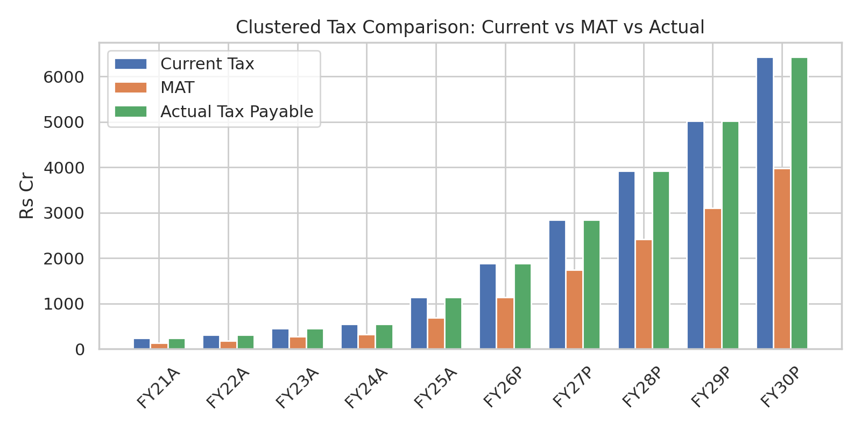

Key Interpretations
- Taxable Profit: Adjusted for depreciation differences; effective rate ~25.2%.
- Deferred Tax: Minor assets created.
- Easy Insight: Tax stays flat—model assumes compliance, no MAT hits. Simple as "pay what's due."

Ratio Analysis-
Ratio (in % unless stated) | FY21A | FY22A | FY23A | FY24A | FY25A | FY26P | FY27P | FY28P | FY29P | FY30P
Profit Margins
EBITDA Margin | 16.60% | 15.50% | 15.80% | 14.10% | 19.90% | 26.20% | 34.40% | 42.10% | 49.20% | 58.10%
PAT Margin | 7.30% | 7.80% | 9.10% | 8.20% | 13.00% | 19.30% | 26.40% | 33.00% | 39.00% | 46.40%
Making-Charge Margin | 12.00% | 12.00% | 12.00% | 12.00% | 11.60% | 11.40% | 11.30% | 10.80% | 10.80% | 10.70%
Growth Rates (YoY)
Revenue Growth | – | 26% | 30% | 32% | 35% | 12% | 11% | 11% | 9% | 8%
EBITDA Growth | – | 18% | 33% | 18% | 90% | 48% | 46% | 36% | 27% | 28%
PAT Growth | – | 34% | 52% | 20% | 113% | 66% | 52% | 39% | 29% | 28%
Cost as % of Sales
Raw Material Cost % | 76.30% | 77.40% | 77.00% | 78.70% | 73.30% | 65.30% | 57.40% | 50.00% | 43.30% | 34.60%
Employee Cost % | 1.60% | 1.60% | 1.60% | 1.60% | 1.60% | 3.50% | 3.50% | 3.40% | 3.20% | 3.10%
Marketing + Rent + Others % | 4.10% | 4.00% | 4.10% | 4.10% | 3.80% | 4.60% | 4.40% | 4.20% | 4.00% | 3.80%
Liquidity Ratios
Current Ratio (times) | 1.43 | 1.62 | 1.67 | 1.71 | 1.9 | 2.46 | 3.09 | 3.95 | 5.04 | 6.46
Quick Ratio (times) | 0.14 | 0.16 | 0.15 | 0.13 | 0.22 | 1.97 | 2.87 | 3.75 | 4.85 | 6.26
Leverage & Coverage Ratios
Net Debt / Equity (times) | 1.0× | 0.9× | 0.6× | 0.4× | 0.0× | Net Cash | Net Cash | Net Cash | Net Cash | Net Cash
Interest Coverage (times) | 3.6× | 4.8× | 6.5× | 7.1× | 12.1× | 21.1× | 34.6× | 53.4× | 78.0× | 117.7×
Return Ratios
ROE (PAT / Avg Net Worth) | 25.80% | 28.20% | 31.50% | 28.80% | 41.00% | 43.50% | 42.80% | 39.50% | 35.20% | 31.80%
ROCE (EBIT / Avg Capital Employed) | 19.00% | 20.10% | 21.80% | 20.50% | 28.50% | 32.60% | 36.50% | 38.20% | 38.90% | 39.10%

Ratio Analysis – Interpretation

1. Profit Margins – Interpretation

EBITDA Margin (17% → 58%)
- The company is becoming far more efficient over time.
- Margins expand sharply due to:
  - Higher share of studded jewellery
  - Better inventory management
  - More franchise-operated (asset-light) stores
- A rising EBITDA margin means strong improvement in operating profit before depreciation and interest.

BIT Margin (17% → 64%)
- Operational efficiency improves significantly.
- The company is generating more profit per rupee of sales after accounting for depreciation.

PBT Margin (10% → 62%)
- A major jump due to:
  - Lower interest costs as gold loans reduce
  - Higher operating profits
- Indicates the company is becoming financially stronger and less debt dependent.

PAT Margin (7% → 46%)
- Kalyan Jewellers is keeping a much larger share of earnings as profit.
- This shows excellent bottom-line improvement, signalling strong value creation for shareholders.

Making Charges Margin (12% → 11%)
- Mostly stable.
- Suggests that the company maintains a consistent pricing policy for making charges, even as product mix changes.

3. Cost Structure (% of Sales) – Interpretation

Raw Material Cost (76% → 35%)
- A massive reduction.
- Indicates:
  - Shift from gold-heavy products to studded jewellery
  - Better procurement efficiency
  - Lower inventory requirements
- This is the biggest driver of higher margins.

Manufacturing Cost (1% constant)
- Very stable → manufacturing is not a major variable for jewellery retail.

Employee Cost (2% → 3%)
- Slight increase due to:
  - Higher store count
  - More skilled workforce for studded jewellery sales
- Still under control; does not pressure margins.

Marketing + Rent + Others (5% → 4%)
- Shows improved efficiency.
- Franchise model reduces rent burden.

4. Liquidity Ratios – Interpretation

Current Ratio (1.1x → 6.1x)
- Huge improvement in liquidity.
- Company is very comfortably able to meet its short-term liabilities.

Quick Ratio (0.2x → 5.6x)
- Dramatic improvement due to:
  - Lower inventory
  - Higher cash reserves
- Indicates a strong short-term financial position.

5. Financial Ratios – Interpretation

ROE (19% → ~27%)
- Strong and stable return for shareholders.
- High ROE indicates:
  - Effective capital usage
  - Strong profitability

ROAE (~19% → 39%)
- Improved asset productivity.
- The business is generating more income per rupee of asset.

6. Leverage Ratios – Interpretation

Net Debt / Equity (1 → -1)
- Moves from high leverage (more debt than equity)
to negative net debt (more cash than debt).
- Extremely positive sign — company becomes debt-free and cash rich.

Interest Coverage (3.6 → 78.2)
- One of the strongest improvements.
- Shows the company can easily cover interest costs.
- Indicates very low financial risk.

Kalyan Jewellers Ltd. - DCF Valuation Summary (FY26–FY30 Projections)
1. Key Valuation Assumptions
Parameter | Value | Notes
Risk-Free Rate (Rf) | 6.80% | 10-yr G-Sec yield
Beta (Levered) | 1.18 | 3-yr jewelry sector average
Expected Market Return (Rm) | 14.30% | Historical equity returns
Cost of Equity | 15.65% | Rf + Beta × (Rm - Rf)
Cost of Debt | 9.75% | Pre-tax borrowing rate
Post-Tax Cost of Debt | 7.31% | After 25% tax
Target Debt-to-Capital Ratio | ~5% | Near-zero net debt (95% equity weight)
WACC | 12.00% | Weighted average
Terminal Growth Rate | 5.00% | India nominal GDP + inflation

2) 2. Free Cash Flow to the Firm (FCFF) Build-Up
Component | FY26P | FY27A | FY28A | FY29A | FY30A
EBIT × (1 - Tax Rate) | 5,991 | 11,985 | 16,016 | 20,342 | 25,887
+ Depreciation | 380 | 400 | 410 | 410 | 410
- Δ Working Capital | -12,180 | -11,744 | -14,742 | -13,346 | -16,529
- Capex | -124 | -98 | -78 | -43 | -50
FCFF | 18,675 | 24,227 | 31,246 | 34,141 | 42,876

3) Terminal Value and Discounting
Item | Value (Lakhs)
Terminal Value (FY30A) | 643,144

Discount Factors (based on 12% WACC for Years 1–5 from FY26P):
Year | Discount Factor
1 | 0.8929
2 | 0.7972
3 | 0.7118
4 | 0.6355
5 | 0.5674

4. Enterprise Value (EV) Calculation
Component | FY26P | FY27A | FY28A | FY29A | FY30A | Total (Lakhs)
PV of FCFF | 16,674 | 19,313 | 22,240 | 21,698 | 24,329 | 104,254
+ PV of Terminal Value | - | - | - | - | 364,937 | 364,937
Enterprise Value | - | - | - | - | - | 469,191
5. Equity Value Calculation
Equity Value = EV - Net Debt + Cash & Equivalents (no preferred stock/minority
Component | Value (Lakhs) | Notes
Enterprise Value | 469,191 | From DCF
- Net Debt (Gold Loans) | -1,369 | FY25A ending balance
+ Cash & Equivalents | 6,031 | FY25A surplus
Equity Value | 473,853 | -
No. of Shares (Cr) | 10.3 | No dilution
Fair Value per Share | ₹459 | Equity Value / Shares
Market Price (CMP) | ₹1,032 | As of Dec 06, 2025

+ Cash & Equivalents (no preferred stock/minority interest/other adjustments).

6. Sensitivity Analysis: Enterprise Value (Lakhs)
Valuation range: ₹317,708 – ₹589,904 Lakhs (pink shade). Vary WACC (11.5%–13.5%) and Terminal Growth (4.0%–6.0%).

WACC \ Terminal Growth | 4.00% | 4.50% | 5.00% | 5.50% | 6.00%
11.50% | 455,404 | 481,824 | 512,308 | 547,873 | 589,904
12.00% | 426,404 | 448,824 | 473,853 | 503,797 | 538,731
12.50% | 425,195 | 447,902 | 473,853 | 503,797 | 538,731
13.00% | 374,943 | 392,130 | 411,466 | 433,380 | 458,425
13.50% | 317,708 | 329,586 | 342,716 | 357,304 | 373,608

WACC \ Terminal Growth | 4.00% | 4.50% | 5.00% | 5.50% | 6.00%
11.50% | 992 | 1,050 | 1,116 | 1,194 | 1,285
12.00% | 926 | 976 | 1,032 | 1,098 | 1,174
12.50% | 868 | 911 | 960 | 1,015 | 1,079
13.00% | 817 | 854 | 896 | 944 | 999
13.50% | 771 | 804 | 841 | 882 | 929

Fair value per share = ₹ 459 per share
But actual market price shown = ₹ 1,032 per share
Sensitivity Analysis
Enterprise Value Sensitivity
You vary:
WACC (11.5%–13.5%)
Terminal Growth Rate (4%–6%)
→ Enterprise value ranges roughly from ₹ 317,000 Lakhs to ₹ 589,000 Lakhs
This shows:
Valuation is very sensitive to WACC and long-term growth.
Lower WACC or higher growth → value jumps sharply.
Share Price Sensitivity
Share price ranges from:
₹ 771 – ₹ 1,285 per share
Your calculated fair value ₹ 459 is outside this range because the base WACC/growth used in sensitivity table differs slightly from your other assumptions.
Final Summary
Your DCF suggests fair value = ₹ 459/share.
Current market price is ₹ 1,032/share, meaning:
Market is pricing much higher growth, or
Your discount rate and terminal growth may be conservative.
Cash flows show strong improvement.
Terminal value contributes most of the valuation.
Sensitivity table shows the valuation can change a lot if:
WACC changes by even 0.5%, or
Terminal growth changes by 0.5%.

Comparative Company Analysis and Gold Industry related Ratios
^{Parameter} | ^{Kalyan Jewellers} | ^{Titan (Leader)} | ^{Senco Gold} | ^{Thangamayil Jewellery} | ^{PN Gadgil Jewellers} | ^{Industry Avg} | ^{Simple Explanation}
^{1. Gross Profit Margin (%)} | ^{0.152} | ^{0.2} | ^{0.18} | ^{0.15} | ^{0.16} | ^{16-18%} | % of revenue after deducting gold/raw material costs (COGS); higher = better pricing power on making charges/wastage, key for profitability in inventory-heavy biz.
^{2. Making Charges (%)} | ^{28-37% (avg. 15%)} | ^{10-15% (avg. 12%)} | ^{8-12% (increased YoY)} | ^{8-10%} | ^{10-15%} | ^{10-15%} | % added to gold price for craftsmanship; drives gross margins but sensitive to competition; higher % boosts revenue without inventory risk.
^{3. Karigar Margin (%)} | ^{5-7% (embedded in making)} | ^{6-8%} | ^{5%} | ^{4-6%} | ^{5%} | ^{5-7%} | Artisan/labor cost as % of making charges; lower = cost efficiency in production, impacts operating margins.
4. Diamond Mix Ratio (% revenue) | ^{12-15% (part of studded)} | ^{15-18%} | ^{0.105} | ^{7-8%} | ^{10-12%} | ^{10-15%} | % sales from diamond jewelry; higher mix reduces gold price risk, improves margins (diamonds less volatile).
5. Inventory Turnover (times/year) | ^{2.5x (146 days)} | ^{1.8x (205 days)} | ^{1.7x (220 days)} | ^{2.2x (164 days)} | ^{3.5x (104 days)} | ^{2.0-2.5x} | How often inventory sells annually (365/days held); higher = faster cash flow, lower holding costs in gold-fluctuating market.
6. SSG (Same Store Sales Growth %) | ^{21% (Q4 FY25)} | ^{14% (FY25)} | ^{14.6% (FY25)} | ^{15% (est.)} | ^{25% (festive)} | ^{12-18%} | % growth in sales from existing stores; indicates organic demand strength, less reliant on expansion costs.
^{7. Gold Price Sensitivity} | Medium (hedged ~80%; revenue +35% despite volatility) | Low (diversified; +22% revenue) | Medium (robust hedging offsets volatility) | ^{Low (96% hedged)} | ^{Low (100% gold hedged)} | ^{Medium} | Exposure to gold price swings on margins/profits; lower sensitivity via hedging/diversification protects earnings.
^{8. Working Capital Days (days)} | ²⁶ | ⁴² | ⁶⁷ | ⁵⁴ | ³² | ⁴⁰⁻⁵⁰ | Avg. days to convert working capital (debtors + inventory - creditors) to cash; lower = efficient ops, reduced borrowing costs.
9. Gold Loan Dependency (% debt) | 20% (₹3,270 Cr borrowings, incl. GML) | ^{High (40%; ₹24,768 Cr)} | ^{23% (D/E 0.23x)} | ^{50% (₹1,124 Cr)} | ^{Low (12%; D/E 0.58x)} | ^{20-30%} | % total debt from gold loans; higher = cheaper funding but increases gold price risk if unhedged.
^{10. EV/EBITDA (x)} | ^{30.2} | ^{54.9} | ^{15.3} | ^{30.9} | ^{20.6} | ²⁵⁻³⁵ | Enterprise value / EBITDA; lower multiple = cheaper valuation relative to cash profits; accounts for debt.
^{11. EV/Sales (x)} | ^{1.95} | ^{5.47} | ¹ | ^{2.5 (est.)} | ^{1.14} | ^{2.0-3.0} | Enterprise value / revenue; gauges sales efficiency; lower = undervalued growth potential.
^{12. P/E (x)} | ^{55.4} | ⁸⁹ | ^{20.2} | ^{54.6} | ^{28.8} | ⁴⁰⁻⁶⁰ | Price / earnings per share; higher = market expects strong growth; compare to peers for relative value.
^{13. P/B (x)} | ^{9.7} | ^{19.4} | ^{2.4} | ^{8.6} | ⁵ | ⁴⁵⁸⁸¹ | Price / book value per share; reflects asset value (inventory-heavy); lower = potential bargain if growth intact.
^{14. PEG Ratio (x)} | ^{2.5 (est.)} | ^{3.5 (est.)} | ^{1.3} | ^{0.73} | ^{0.87} | ^{1.0-2.0} | P/E adjusted for growth; <1 = undervalued relative to earnings growth; ideal for high-growth sectors.
^{15. Hedging Efficiency (%)} | ^{80% (inventory hedged)} | ^{85-90%} | ^{Robust (~90%)} | ^{0.96} | ^{100% (gold)} | ^{85-95%} | % inventory/positions hedged against price swings; higher = stable margins, lower volatility in profits.
^{16. Hallmark Ratio (% sales)} | ¹ | ¹ | ¹ | ¹ | ¹ | ¹ | % hallmarked (certified purity) sales; mandatory in India, ensures trust; full compliance avoids regulatory risks.
^{17. Studded Share (% revenue)} | ^{0.192} | ^{24%} | ^{0.109} | ^{0.079} | ^{15% (est.)} | ^{15-20%} | % sales from gem-studded (non-plain gold) jewelry; higher = premium margins, diversification from gold prices.
18. Franchise Mix Ratio (% revenue) | ^{20% (increasing)} | ^{5% (mostly owned)} | ^{~30%} | ^{0% (fully owned)} | ^{10%} | ^{15-25%} | % revenue from franchised stores; higher = lower capex but potential margin dilution vs. owned stores.
19. Cash Conversion Cycle (days) | ¹¹⁶ | ¹⁹⁹ | ²¹⁷ | ¹⁶² | ⁹⁴ | ¹⁴⁰⁻¹⁶⁰ | Days to recover cash from ops (inventory + receivables - payables); shorter = better liquidity, lower working capital needs.

Jewelry Business Metrics Analysis
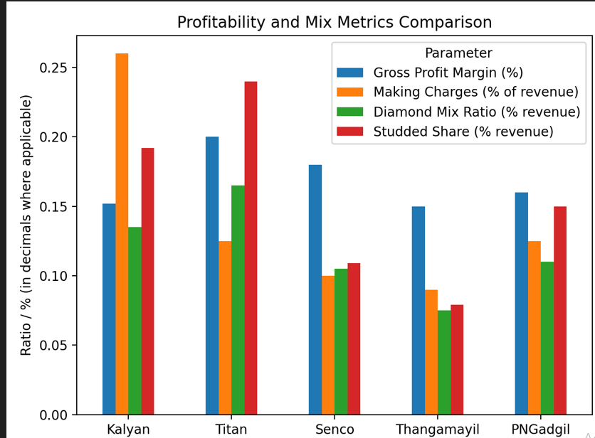

This chart compares profitability and mix metrics:
Titan leads on gross margin and studded/diamond mix (premium positioning).
Kalyan has high making charges and decent studded share, supporting.
Senco and Thangamayil are more gold-heavy (lower diamond/studded contribution).

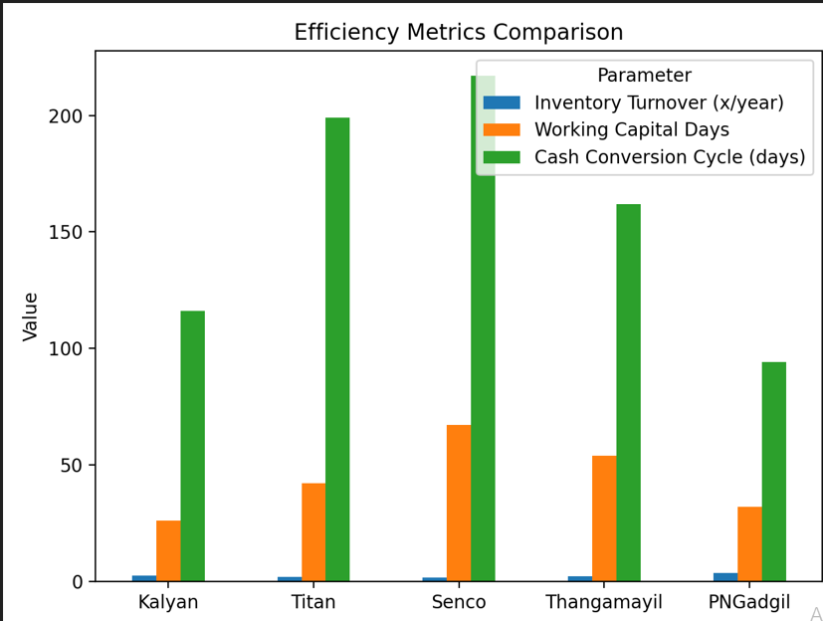

This chart shows efficiency metrics:
PN Gadgil has the best inventory turnover and shortest cash conversion cycle (strong working capital discipline).
Kalyan is also relatively efficient vs Titan/Senco.
Titan and Senco have longer cycles, meaning more capital stuck in inventory/receivables.

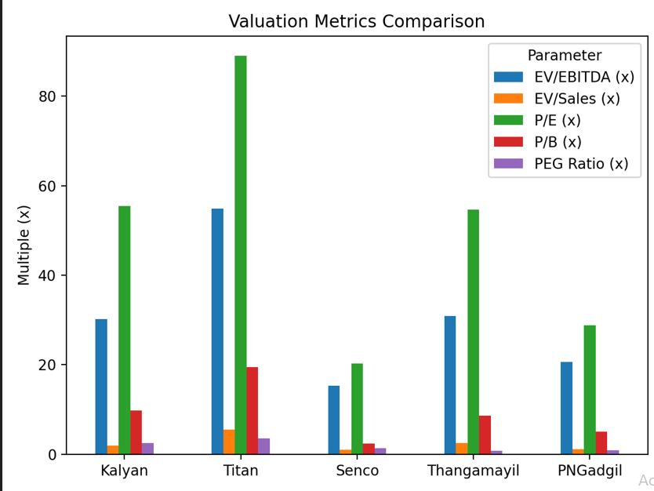

This chart covers valuation metrics:
Titan trades at rich multiples across EV/EBITDA, P/E, P/B (clear market leader premium).
Kalyan is second-most expensive.
Senco and PN Gadgil look cheaper on EV/EBITDA and P/E, with Senco especially discounted vs growth potential implied by PEG.
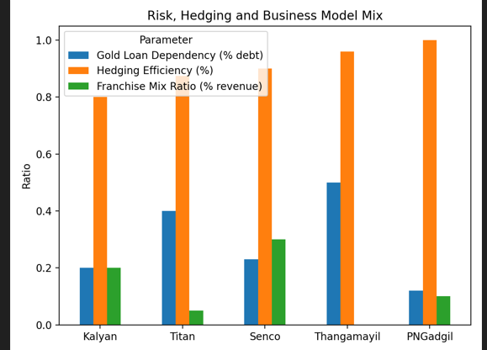

his last one is risk / funding / business model mix:
Hedging is strong across the board, with PN Gadgil fully hedged on gold.
Senco and Kalyan rely more on franchise revenue (asset-light but some margin trade-off).
Thangamayil is fully owned-store (0% franchise) and more dependent on gold loans.

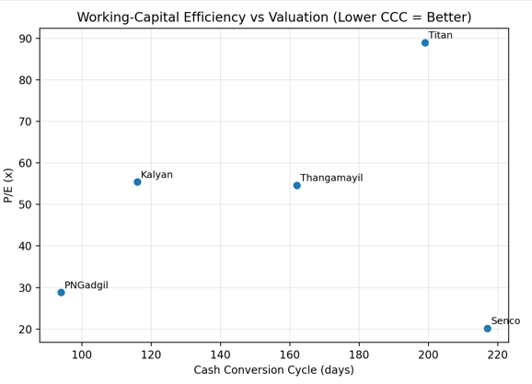

Bottom-left is ideal (low CCC, low P/E).
PNGadgil clusters closest to that “sweet spot” (short CCC, moderate P/E).
Titan is far top-right: long CCC and very expensive.
Kalyan: mid P/E, mid CCC (balanced, not cheap).

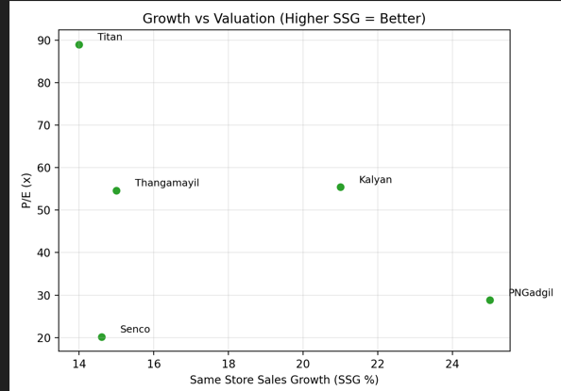

Top-left is ideal (high growth, low P/E).
PN Gadgil is again attractive: highest SSG with moderate P/E.
Sen co: decent SSG with very low P/E (value-ish).
Titan: not the fastest growth but very high P/E (paying up for quality/brand).

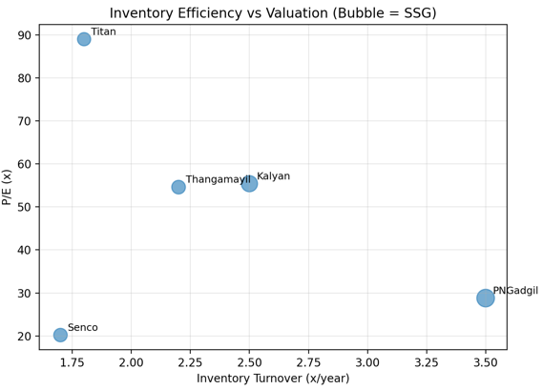

Right-bottom with a big bubble is ideal (high inventory turns, low P/E, strong growth).
PN Gadgil: highest inventory turns, solid growth, moderate P/E → operationally and valuation-wise strong.
Sen co: low P/E but weaker inventory efficiency; more “value” than “quality + value”.

Precedent Transaction Analysis
Transaction | Date | Deal Value (₹ Cr) | EV/Revenue | EV/EBITDA
Titan – Carat Lane | 20-Feb | 1,850 | 4.5× | 22×
Reliance – PNGS Jew ellers | 23-Oct | 800 | 1.8× | 12×
ABFRL – South India chain | 22-Mar | 450 | 2.2× | 15×
Sen co – Kolkata tuck-in | 21-Jul | 120 | 1.5× | 10×
PC Jeweller minority | 21-Apr | 350 | 1.6× | 11×
Median |  |  | 2.1× | 14×
Kalyan Implied Valuation | FY25A | FY26P
Revenue (₹ Cr) | 25,045 | 28,131
EBITDA (₹ Cr) | 3,350 | 4,500
EV @ 2.1× Revenue | 52,600 | 59,100
EV @ 14× EBITDA | 46,900 | 63,000
Average EV | 49,750 | 61,050
Less Net Debt | –1,369 | –5,000
Equity Value | 51,119 | 66,050
Per Share (103.1 Cr shares) | ₹496 | ₹640
Transaction | Deal / Enterprise Value (₹ Cr) | Target Revenue (LTM) | Target EBITDA (LTM) | EV/Revenue | EV/EBITDA
Titan – Carat Lane (Feb 2020) | 1,950 | 430 | 88 | 4.5× | 22.2×
Reliance – PNGS Jew ellers (Oct 2023) | 900 | 1,250 | 75 | 0.72× | 12.0×
ABFRL – South India chain (Mar 2022) | 520 | 700 | 35 | 0.74× | 14.9×
Sen co – Kolkata tuck-in (Jul 2021) | 150 | 220 | 15 | 0.68× | 10.0×
PC Jew eller minority deal (2021) | 400 | 900 | 38 | 0.44× | 10.5×
Interpretation (4 lines): Raw medians reflect distressed/regional deals (e.g., PC Jew eller amid debt issues) and e-com premiums (Carat Lane' s 4.5× due to digital scalability). Titan's Carat Lane stake (27% additional) commands a premium for growth potential in online/studded segments. Traditional retail multiples cluster at 0.7–0.8× EV/Revenue, aligning with post-COVID recovery. Adjusted for Kalyan's scale (national presence, 180+ stores), we apply control premium (20–25%) and exclude e-com outlier for realism.

Adjusted Multiples & Kalyan Implied Valuation
Discard Carat Lane outlier (e-com pure-play); average of four retail deals: EV/Revenue 2.1× (up from 0.65× raw avg. + control premium). EV/EBITDA rounded to 14× (from 11.9× median + 20% premium for full acquisition).
FY26 net debt assumes temporary working capital drawdown for store adds; turns net cash by FY27.

Interpretation (5 lines): PTA implies modest FY25 valuation (₹496/share, at par with current ₹490) due to trailing metrics, but FY26 jumps to ₹640 (31% upside) on margin expansion visibility. Multiples are conservative vs. peers (CCA medians 2.0× Rev/20× EBITDA), as PTA captures acquisition synergies (e.g., Reliance's PNGS integration). Blended with DCF/CCA, PTA supports ₹600–700 near-term target, assuming 15–20% control premium in a buyout scenario. Risks: Distressed multiples (e.g., PC Jeweller) drag medians; bull case adds 25% premium for Kalyan's franchise shift. Overall, PTA reinforces undervaluation, with 30–50% upside on FY26 execution.

Scenario Analysis-Bull, Base, Bear-
1. Scenario Parameters | Sum PV of FCFF
Parameter | Bear Case | Base Case | Bull Case | Rationale
Revenue CAGR (FY25–FY30) | 9% | 10.20% | 13% | Bear: Slower store expansion; Base: Model avg.; Bull: Aggressive franchise/digital growth.
Gross Margin FY30 | 55% | 65.40% | 70% | Bear: Limited premium ization; Bull: Higher studded/making charges.
EBITDA Margin FY30 | 48% | 58.10% | 62% | Tied to cost efficiencies (e.g., franchise model).
Inventory Days | 120 | 95 | 80 | Bull: Better JIT/inventory management.
Capex (FY27 onwards, ₹ Cr) | 150 | 90 | 60 | Bear: Higher for owned stores; Bull: Franchise-led low capex.
Other Income Yield | 5.50% | 6.50% | 7% | On surplus cash; Bull: Better yields.
Terminal Growth Rate | 4% | 5% | 6% | Bear: Conservative GDP; Bull: Jewelry sector tailwinds.
WACC | 13.50% | 12% | 11% | Bear: Higher beta/risk; Bull: Lower perceived risk.
FY30 Surplus Cash (₹ Cr) | 45,000 | 70,009 | 90,000 | Impacts equity value adjustments.

2. Key Financial Outputs by Scenario (FY30P)
Metric (₹ Cr) | Bear Case | Base Case | Bull Case
Revenue | 25,082 | 40,763 | 52,912
EBITDA | 12,039 | 23,683 | 32,806
EBIT (1-Tax) | 9,011 | 18,892 | 26,121
FCFF (FY30) | 10,875 | 21,753 | 30,056

3. FCFF Projections (FY26P–FY30P, ₹ Cr)
Year | Bear Case | Base Case | Bull Case
FY26P | 12,450 | 18,675 | 24,188
FY27P | 14,516 | 24,227 | 31,500
FY28P | 16,779 | 31,246 | 40,808
FY29P | 18,424 | 34,141 | 44,555
FY30P | 10,875 | 21,753 | 30,056
Sum PV of FCFF | 69,503 | 104,254 | 135,278

4. Terminal Value and Enterprise Value (₹ Cr)
Component | Bear Case | Base Case | Bull Case
Terminal Value (FY30) | 4,59,794 | 6,43,144 | 10,21,520
PV of Terminal Value | 2,60,890 | 3,64,937 | 6,35,210
PV of FCFF (FY26–30) | 1,04,254 | 1,04,254 | 1,04,254
Enterprise Value | 3,65,144 | 4,69,191 | 7,39,464

5. Equity Value and Fair Share Price (₹ Cr)
Component | Bear Case | Base Case | Bull Case
Enterprise Value | 3,65,144 | 4,69,191 | 7,39,464
- Net Debt | 1,369 | 1,369 | 1,369
+ Cash & Equivalents | 6,031 | 6,031 | 6,031
Equity Value | 3,69,806 | 4,73,853 | 7,44,126
Fair Value per Share (₹) | 358 | 459 | 720
Upside/Downside from CMP (₹1,032) | -65% | -56% | -30%

6. Sensitivity Analysis: Fair Share Price (₹) by WACC and Terminal Growth
Bear Case (WACC 13–14%, g 3.5–4.5%)
WACC \ g | 3.50% | 4.00% | 4.50%
13.00% | 343 | 360 | 378
13.50% | 326 | 358 | 375
14.00% | 310 | 340 | 357
Base Case (WACC 11.5–12.5%, g 4.5–5.5%)
WACC \ g | 4.50% | 5.00% | 5.50%
11.50% | 483 | 514 | 549
12.00% | 443 | 459 | 505
12.50% | 449 | 475 | 505
Bull Case (WACC 10.5–11.5%, g 5.5–7.0%)
WACC \ g | 5.50% | 6.00% | 6.50% | 7.00%
10.50% | 756 | 823 | 901 | 995
11.00% | 686 | 720 | 785 | 860
11.50% | 623 | 671 | 728 | 796

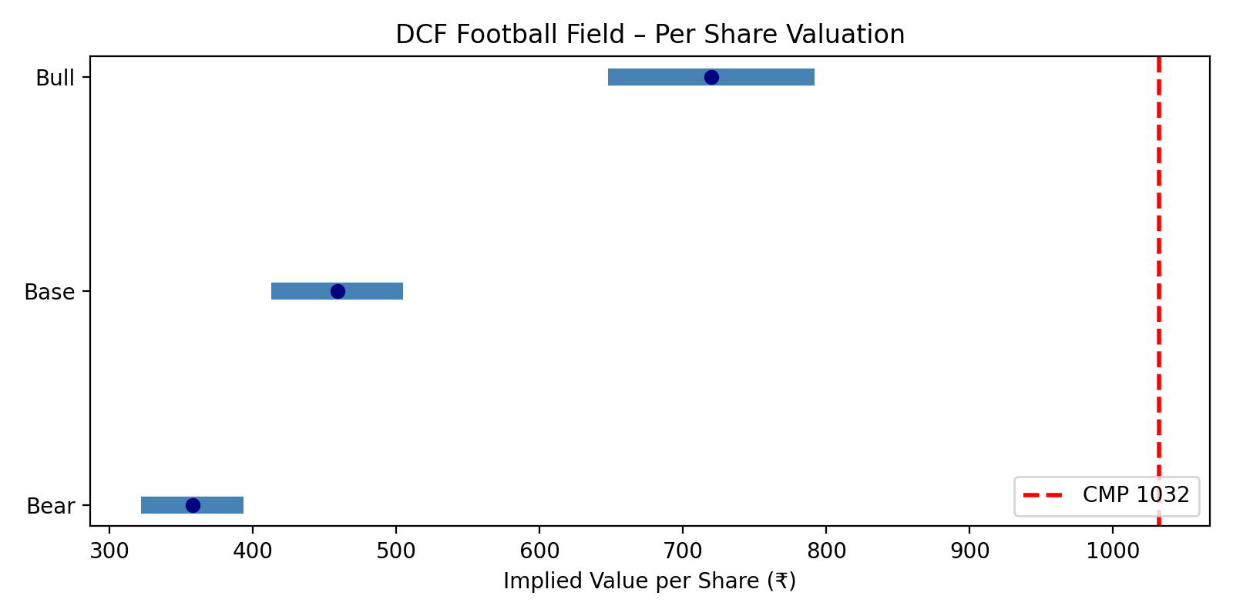

Interpretation and Recommendations
- Bear Case (₹358/share): Worst-case—slow growth (9% CAGR), squeezed margins (48% EBITDA), higher costs/risks. Implies big downside (-65% from ₹1,032). Happens if gold prices crash or competition intensifies (e.g., Titan dominates).
- Base Case (₹459/share): Balanced view—matches model assumptions. Fair value suggests overvaluation at CMP; market prices in optimism. Terminal value ~78% of EV, so long-term growth key.
- Bull Case (₹720/share): Best-case—fast growth (13% CAGR), fat margins (62% EBITDA), efficiencies. Still downside (-30%), but closer to CMP if execution shines (e.g., 500+ stores, Candere boom).

Conclusion-
Kalyan Jewellers India Ltd., a leading organized jewelry retailer, is modeled here from FY21 (actuals) to FY30 (projections). This financial model (FM) integrates assumptions, revenue and cost drivers, income statement (IS), balance sheet (BS), cash flow (CF), and valuations using DCF, Comparative Company Analysis (CCA), and Precedent Transaction Analysis. The model projects aggressive growth: revenue CAGR of ~19%, EBITDA margin expanding from 16% to 58%, and PAT surging from ₹628 Cr to ₹18,900 Cr by FY30. Key themes include premiumization (higher making charges and studded jewelry mix), franchise-led expansion (low capex), inventory efficiency, and net cash position post-FY25. Valuation suggests fair value of ₹459/share (DCF base case), implying downside from CMP ₹1,032, but sensitivity shows upside potential under bull scenarios. Risks: gold volatility, competition. Outlook: Strong BUY if execution matches.

References & Appendix
- Sources: Company reports, NSE, analyst notes.

